The characteristic of a field is the smallest positive integer n such that n.1 = 0. If no such integer exists then we say that the field has characteristic zero.

If K and k are fields, we say that K is an extension of k if k ⊆ K.

F is a field, K is an extension of F, a ∈ K. a is separable over F if it satisfies a polynomial over F having no multiple roots. K is a separable extension of F if ∀a ∈ K, a is separable over F.

The extension field K of F is a splitting field for the polynomial f(x) ∈ F(x) if:
- f(x) factors completely into linear factors in K[x] and;
- f(x) does not factor completely into linear factors over any proper subfield of K containing F.

e.g. The field extension Q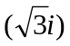 is the splitting field for 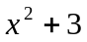 as it is the smallest field containing its roots 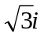and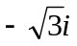.

A Galois extension K of F is the splitting field for a collection of separable polynomials. If K is finite then only one separable polynomial is necessary.

K ⊆ L. The group Aut_{K}(L) of K-automorphisms of L is called the Galois group of the extension and is written Gal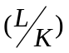.

F_{p}((t)) is the ring of polynomials over t with coefficients in F_{p} such that there are only a finite number of negative powers of t but possibly an infinite number of positive powers.

F_{p}[[t]] is as above but with no negative powers.

A valuation is a map v: K→ Z ∪ {∞} e.g. K = F_{p}((t)).
v(a) = ∞ ⇔ a = 0. v(ab) = v(a) + v(b) v(a + b) ≥ min{v(a), v(b)}
This forms a metric space on K, the distance function being d(a, b) =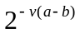. If v(a) ≠ v(b), then v(a + b) = min{v(a), v(b)}. The metric space is complete as every Cauchy sequence converges e.g. 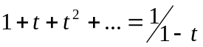.
a ≠ 0, 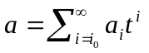, 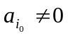. Then v(a) = e.g. v(1 + t) = 0, v(t⁻²) = -2 etc.

The valuation ring is O = {a⏐v(a) ≥ 0}.
Let O = K[[t]]. O has a maximal ideal p = {a⏐v(a) > 0}, p = (t) = 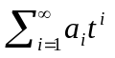. O / p is the residue class field and in this example is F_{p}. In general, it is required to be a finite field as it is here.

A local field of characteristic p is isomorphic to F_{q}((t)) for some q.

K < L – local fields. v_{K:} K→ Γ_{K} ∪ {∞}, Γ_{K} ≅ Z
v_{L:} L → Γ_{L} ∪ {∞}, Γ_{L} ≅ Z
Then v_{K} = v_{L}⏐_{K}, Γ_{K} ≤ Γ_{L} and for the residue fields F_{K} ≤ F_{L}.
⏐Γ_{L} : Γ_{K}⏐= e, ⏐F_{L} : F_{K}⏐ = f, ⏐L : K⏐ = n.

Theorem: n = e×f.

If e = 1, and hence f = n, then the extension is ramified.
If p⏐e then the extension is tamely ramified.
If p⏐e then the extension is wildly ramified.
If, in addition, f = 1 then the extension is totally ramified.

Consider …Z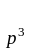→ Z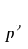→ Z, p a prime and each map the natural surjections.
The p-adic integers is Z_{p} =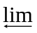Z. The elements of Z_{p} are infinite sequences
(…, a₃, a₂, a₁) with a_{i}∈Z such that a_{i} is the mod p^{i} reduction of a_{i+1}. Z ⊂ Z_{p} by n mapping to (…, n mod p², n mod p).

M is a left R-module. Ann(m) = {r∈R⏐rm = 0}, m∈M. tor(M) = {m∈M⏐Ann(m) ≠ 0}. M is a torsion module if tor(m) = M. M is torsion free if tor(M) = <0>. m∈M is a torsion element if Ann(m) ≠ <0>.

A group G with⎟G⎢= p^{n} and nilpotency class c has coclass n-c.
It has width =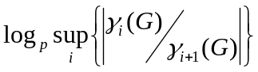.

G is just infinite if it has no proper infinite homomorphic images. G is hereditarily just infinite if it has no non-trivial closed subnormal subgroups of finite index.

